EXPERIMENT – 8
NAME: D SARVESHVARAN ROLL NO: 240701480

Create storyboards to represent the user flow for your application using Balsamiq.

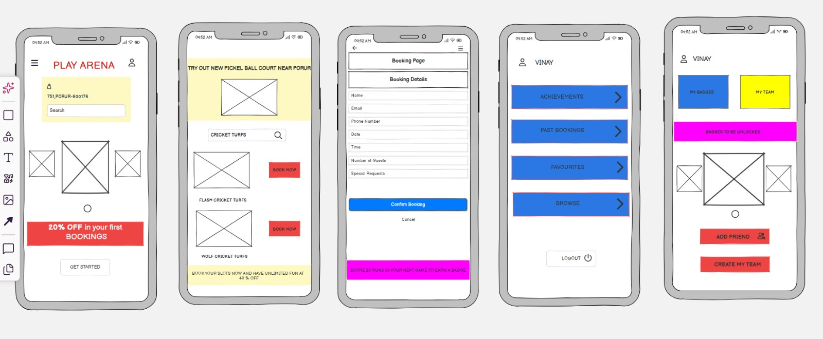

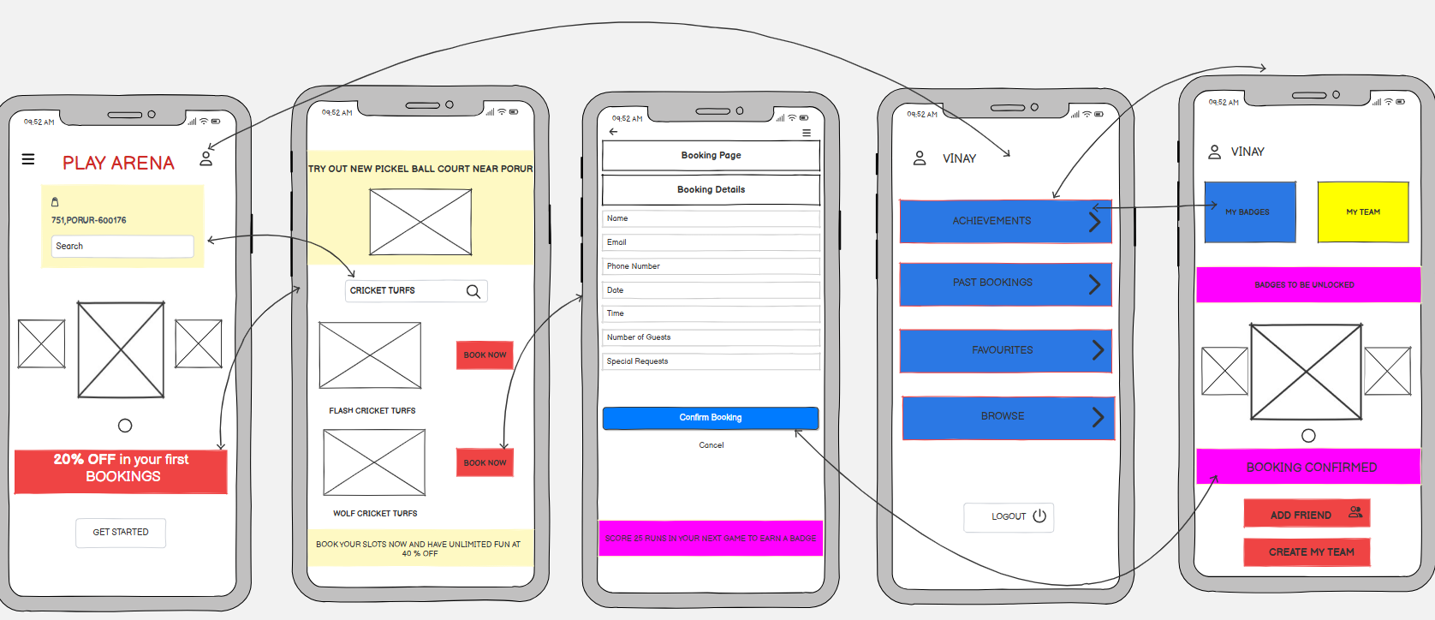

PROTOTYPE LINK: https://balsamiq.cloud/s2ufrgh/pt2nne1/rA310

